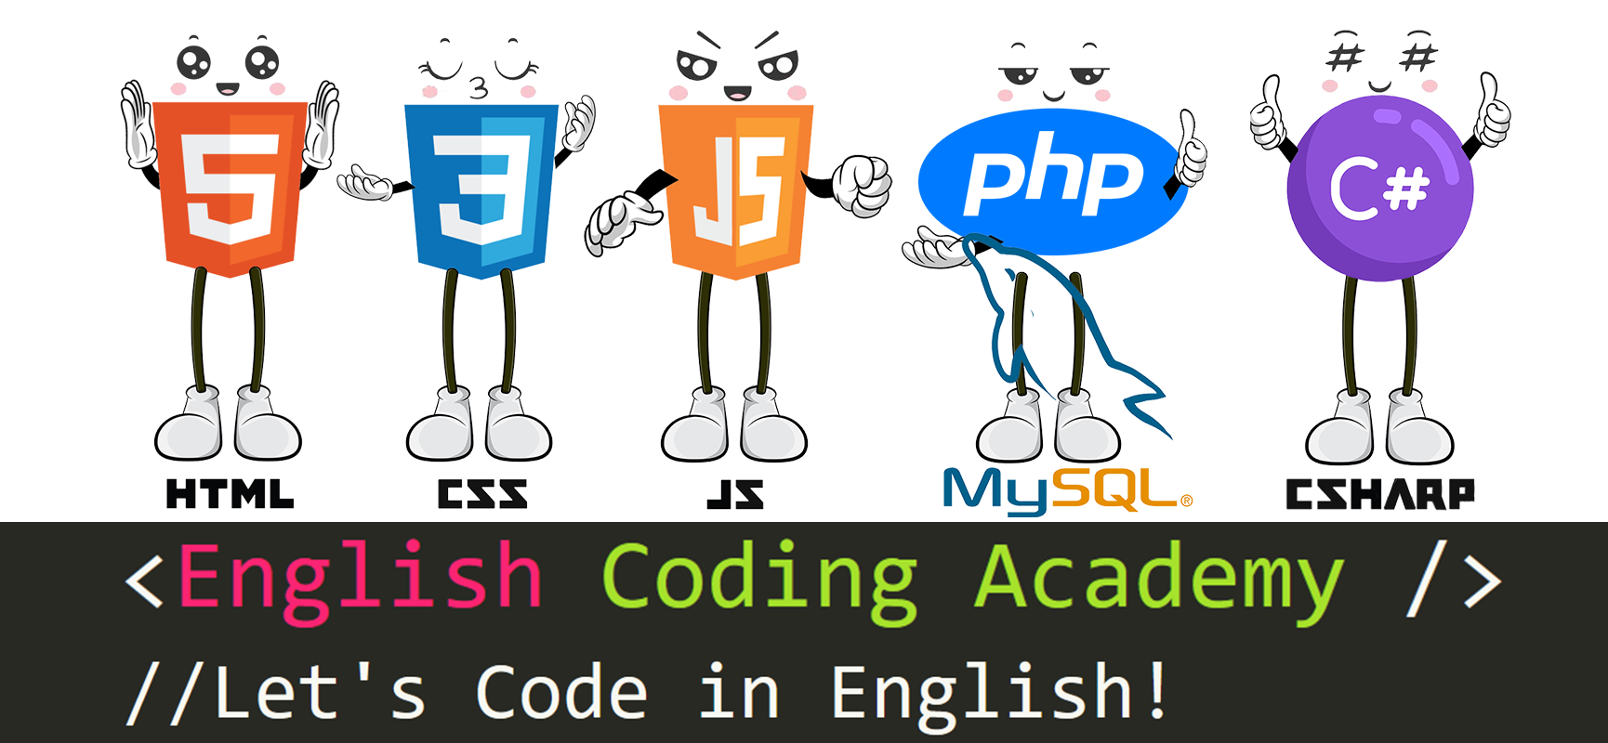

By Shawna Brookes シャナ先生

[www.englishcodingacademy.com/fundamentals.php](http://www.englishcodingacademy.com/fundamentals.php)

**Fundamentals 0: Internet Basics**

**Today’s Lesson: Fundamentals Zero – Internet Basics. By Shawna Sensei.**

**Topics:**

**Files, Clients, Browsers, Network, Servers, Http Request, Http Response.**

The internet is made of many things, like the desktop computers, laptops, tablets, and Smartphones you use every day. It is also made of many things you may not see or notice like cable lines, cell towers, data centers and servers. The internet is a very complicated system.

**Let’s learn some basic parts of the internet:**

You have the file or files, a client, a browser, a network, and a server.

First you have a file or files that contain the code for a website. There are many types of files that make websites “happen.” They have unique “extensions” on their names – an extension example is the “.html” for a file called “index.html” that you may have seen when you visited a website. Basic and common file types are “.html, .php, .css, .js” but there are many more. We will discuss those types later in the course.

Second, you have what is called a “client” – a client is a fancy way of saying “computer, laptop, desktop, or smartphone”. A “client” is simply the device you use to access the internet.

Third, you have a browser. This is a computer program on your laptop, desktop, or smartphone that you use to view websites. There are many web browsers such as Google Chrome, Firefox, Opera, Microsoft Edge, Internet Explorer and Brave.

Fourth, you have the “network.” The network is made of many things. For example, it’s made of cable lines, cell towers, routers, switches, data centers and servers. It’s a very complicated system! But for now just know that it exists!

Lastly, you have a server. A server is part of the network. A server is a type of computer that is specialized for receiving and sending Http requests. It is similar to desktop computers you may have seen or have at home but it has a lot more storage space, a lot more RAM and many processors to handle all the data requests. When you view a web page, you are actually getting the files for that page from a server – and that server can be in a different country thousands of miles away!

**Let’s learn how a basic website request works:**

When you want to look at a website, you often type in in the address in the address bar or click a link. When you type in, for example www.englishcodingacademy.com into the address bar, you are typing in an “URL.” (a Uniform Resource Locator). This is basically an address that you as a human can read and remember easily. Once you press enter or tap the search icon in your web browser, that URL is changed to something the computer and servers can understand.

A “request” is sent from your computer, through the network, to data centers and to a server. The request is sent in what they call a “packet”; for now, just understand that a packet is like a bundle of electronic information.

At the server, it gets your “requests” and the server say’s “oh, this client (ie the computer, the smartphone) wants to see www.englishcodingacademy.com.” So the server gets the files for that web page and sends the files back through the network using a packet to your computer or smartphone. Then your browser takes the files and “renders” them, meaning it changes the files from code into a website that you can actually see on your device.

I hope this basic introduction helps you understand just how complicated and complex the internet is. I hope it inspires you to become interested in a career in Information Technology and Web Development.

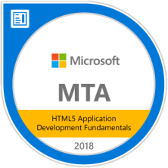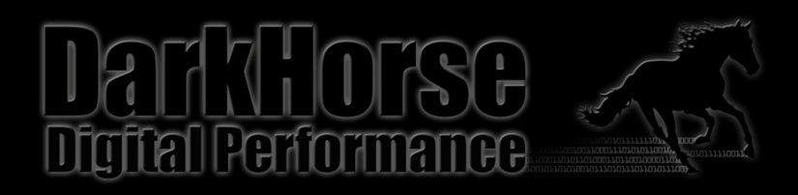[shawnabrookes@gmail.com](mailto:shawnabrookes@gmail.com)

[www.englishcodingacademy.com](http://www.englishcodingacademy.com)

DarkHorse Digital Performance

[www.darkhorsedp.com](http://www.darkhorsedp.com)

[www.brookesportfolio.com](http://www.brookesportfolio.com)